**COMPSCI 345 / SOFTENG 350**

**Tutorial 7: Implementation**

**Worth 1% of your final grade**

**Tutorial exercises should be undertaken in pairs, to discuss and share ideas**

**Each partner must create their own hi-fi prototype and write comments in their own words**

**You should plan to spend 50 minutes on this tutorial, plus 50 minutes from the Assignment 3 hours for familiarity of the Assignment 3 base code**

**Upload your completed HTML file to Canvas**

**Due by 6pm on Friday 22 May**

**Aims**

The aim of this tutorial is to have a first encounter with web implementation technology, and to train adding of functionality to existing web code. The task will be slightly more “functional” than the task required in the assignment 3, with the aim of having done such an implementation once with relatively little pressure, so that the functional part of the assignment remains within that margin.

This task starts from a simple and short template that was used in the lecture (specified under Activity).

**Background**

Your task is to complete the functionality for a websystem “fotostories” that can be deployed on a website, and that is based on the gallery example we discussed in the lecture. We want to be able to show some text that fits to each image, i.e. the text should change with the image selected. The task is chosen so that it is possible to get the code for the solution from the functionality that is included in the template for Assignment 3.

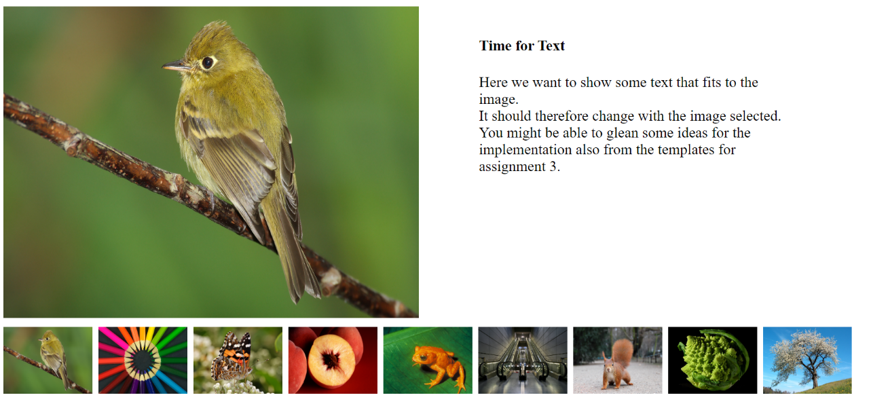

Figure 1. Sample of how a simple system could look like.

**Activity**

To start, in your team, review the code of the Lecture 13 example gallery04Reset.html (from L13samples.zip) and the code of Assignment3_base.html.

Add functionality (from Assignment3_base.html) to gallery04Reset.html, so that associated text to the right of each image appears when the image is clicked. The text should wrap to the correct size. Use the 3 sample texts below for the first 3 images (None of the other images need to be clickable). Please format the text of the headlines.

Text for Image 1:

Yellow bird

This yellow bird ipsum dolor sit amet, consectetur adipiscing elit, sed do eiusmod tempor incididunt ut labore et dolore magna aliqua. Ut enim ad minim veniam, quis nostrud exercitation ullamco laboris nisi ut aliquip ex ea commodo

Text for Image 2:

Multicolour pencils

This flower ipsum dolor sit amet, consectetur adipiscing elit, sed do eiusmod tempor incididunt ut labore et dolore magna aliqua. Ut enim ad minim veniam, quis nostrud

Text for Image 3:

Butterfly

This yellow bird ipsum dolor sit amet, consectetur adipiscing elit, sed do eiusmod tempor incididunt ut labore et

Review the file provided for Assignment 3 to identify the JavaScript functionality that enables the appearance/disappearance of text sections. Adapt that functionality so that it works in gallery04Reset.html. You may consult developer resources (as mentioned in Lecture 14) to better understand the code in Assignment3_base.html.

Make the implementation robust so that it does not break if one of the other images is chosen, for example by copying the same placeholder text to all of them.

Submit your solution as a single HTML file, which should contain your solution, with your own comments to indicate what code that you adapted.

**Tutorial 7 Worksheet Rubric**

*Criteria*

* Implementation function: Quality of functionality: does it work? Is layout preserved without bugs?
* Implementation visuals: is the format of the titles professional?
* Writeup: Implementation changes are commented clearly.

*Assessment of criteria*

Criteria are assessed as excellent, good, satisfactory, unsatisfactory or fail.